Output Of the Code Of Deploy Application On Cloud

1.We setup EC2 in aws

2.To create instance in EC2.

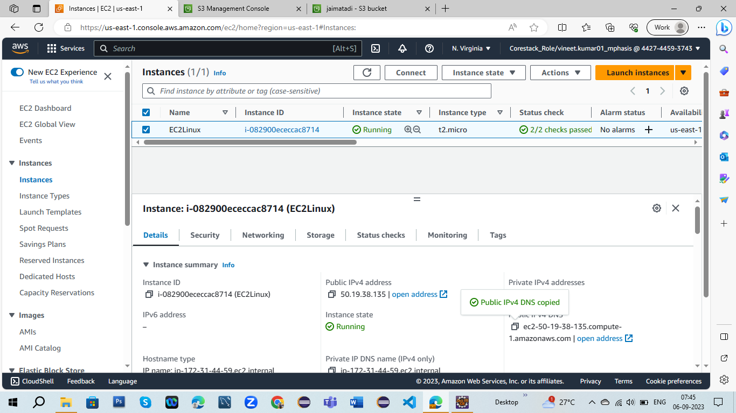

3.After creating instance we need to new instance connect with EC2

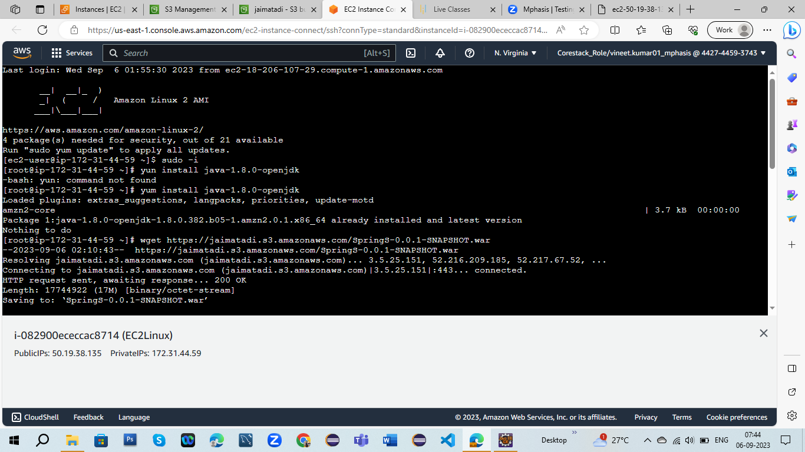

4.After connection now we need to create S3 means create new bucket;

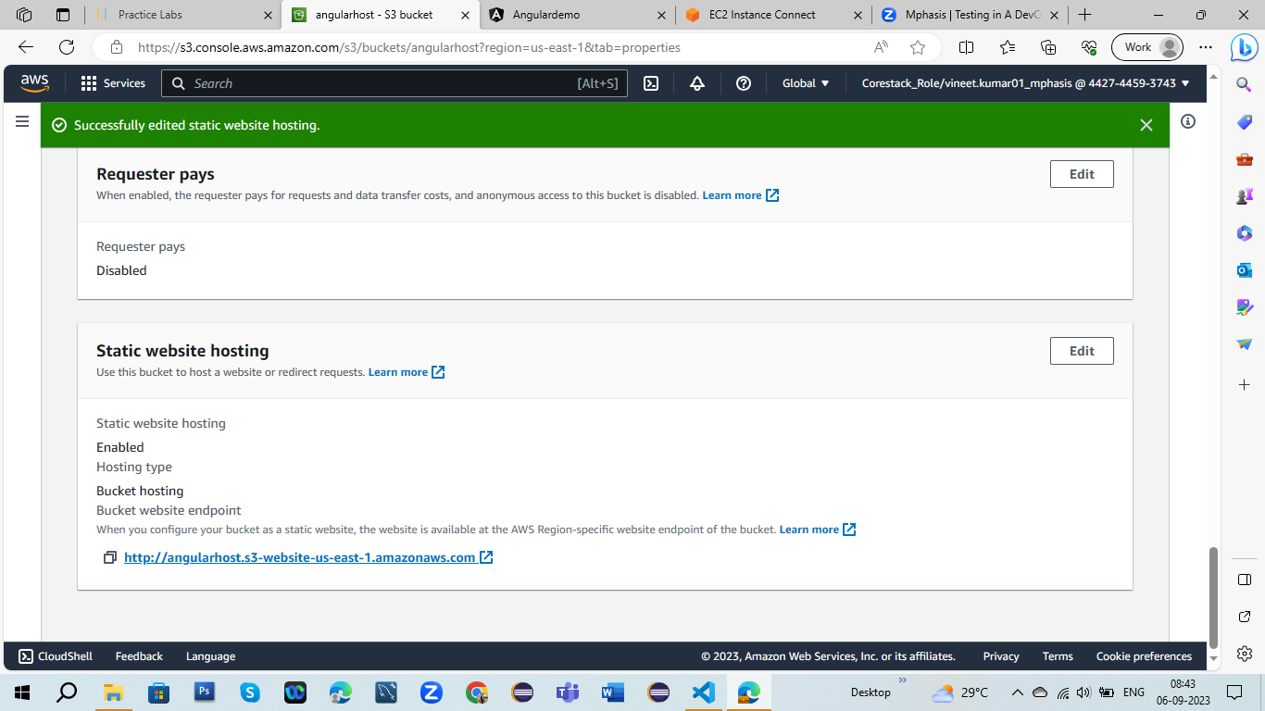

5.After creating new bucket we have to upload the file of main program

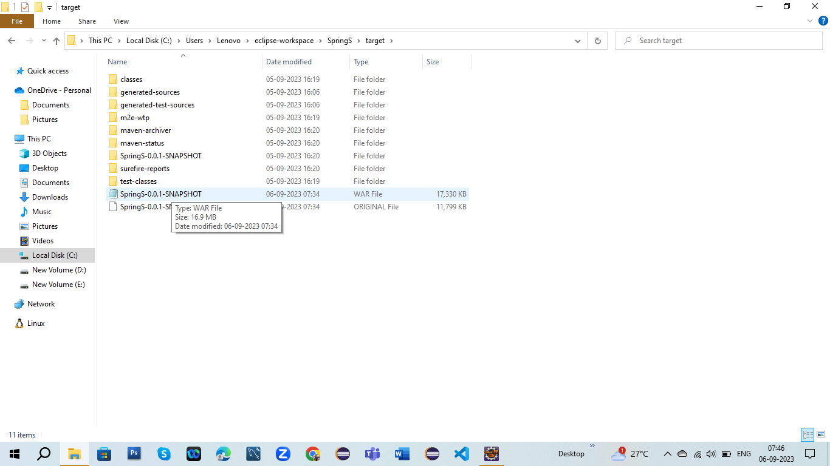

6.Finally upload this file in new bucket.

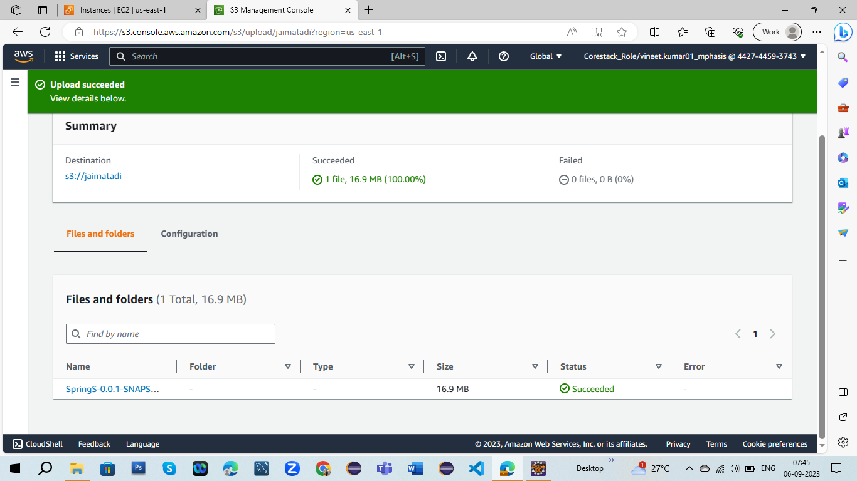

7.After uploading the file ,now we will go to connection page in EC2 and after write few command for output

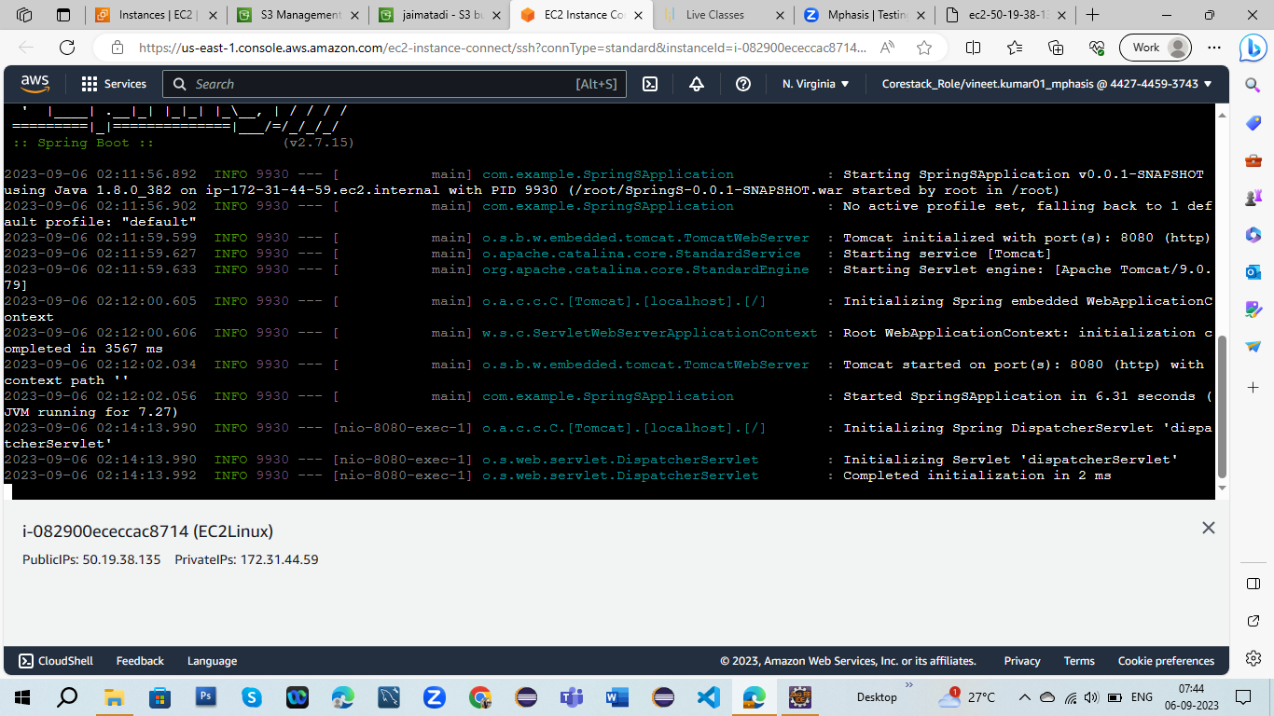



8.Finally I get output using AWS

